2016 Science Education Workshop for High School Teachers (03/10/2016)

The Science Education Workshop sponsored by the Ministry of Science and Technology was held at the National Chiayi University to help teachers to be familiar with hands-on activities. Scientific activities were demonstrated. Teachers can incorporate these activities in teaching to promote students’ interest in learning science.

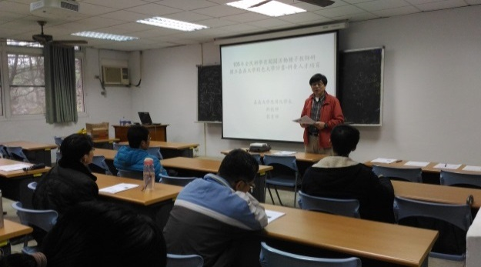 | 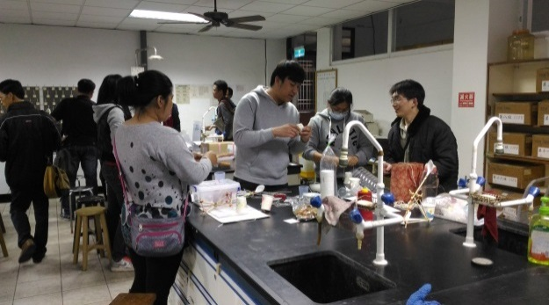
古國隆主任進行開幕致詞 | 教師進行科學闖關活動-蛙鳴器之製備
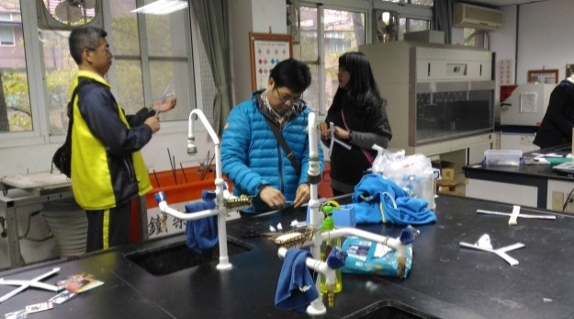 | 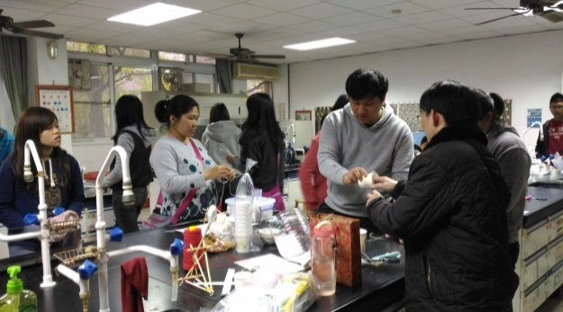
教師進行科學闖關活動-迴力標之製備 | 教師進行科學闖關活動-蛙鳴器之製備

