常用實驗器材中、英文名稱

|  |  |  |
| --- | --- | --- |
|  |  |  |
| 三角燒瓶、錐形瓶  Erlenmeyer flask | 燒杯  Beaker | 抽氣過濾瓶  Filtering flask |
|  |  |  |
| 定量瓶、容量瓶  Volumetric flask | 量筒  Graduated cylinder | 滴定管  Buret |
|  |  |  |
| 刻度吸量管、分度吸量管  Graduated pipet | 移液吸管  Volumetric pipet | 滴管  Dropper |
|  |  |  |
| 試管  Test tube | 漏斗  Funnel | 攪拌棒  Stirring rod |

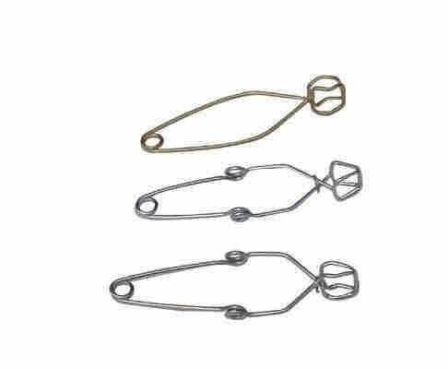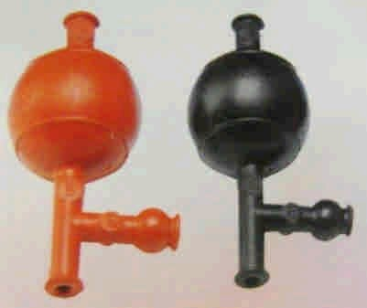

|  |  |  |
| --- | --- | --- |
|  |  |  |
| 蒸發皿  Evaporating dish | 研缽及杵  Mortar and pestle | 藥杓  Spatula |
|  |  |  |
| 温度計  Thermometer | 鐵架  Ring stand | 直交夾  Right angle clamp |
|  |  |  |
| 滴定管夾  Buret clamp | 試管夾  Test tube holder | 試管架  Test tube rack |
|  |  |  |
| 廣用夾、三叉夾  Three prong clamp | 水浴鍋  Water bath pot | 安全吸球  Pipet filler |

|  |  |  |
| --- | --- | --- |
|  |  |  |
| 洗瓶  Wash bottle | 試管刷  Test tube brush | 加熱攪拌器  Hot plate stirrer |
|  |  |  |
| 濾紙  Filter paper | 磁石  Stir bar |  |