**Registration information of working holiday opportunity 2015 firefly season in Nantou County, Taiwan**

**Firefly Participants General Regulations**

1. **Introduction**

The working holiday opportunity in 2015 firefly season is organized by Nantou County that offering a great chance for youngsters to enjoy the attractions of local culture, artifacts and scenery in the heart of Taiwan.

We sincerely invite all the people who are interested in the insight travel and cultural communication to take part of this great activity, share your profession and viewpoints with partners from different places around the world, and develop the exceptional local living experience in Nantou County.

1. 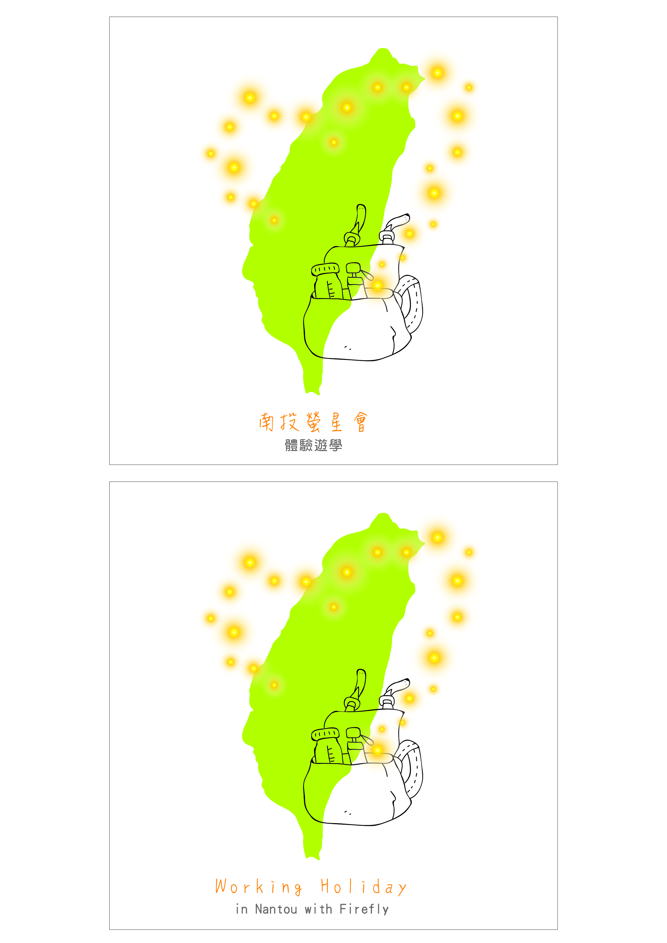**Organizers and Sponsors**

Instructor: SMEA, MOEA (Small and Medium Enterprise Administration, Ministry of Economy Affairs)

Organizer: Nantou County Government

Executers: Innovation Center of Nantou Cultural Industry, GEO INFORMATICS INC.

Sponsors: Nantou Homestay Tour Association, Townway Co., Happymore4you Co., King Taiwan B&B , Leader Hotel Chi Tou, Greenriver Eco and Culture B & B, Greenlake B&B, Akei B&B, Hoti holiday B&B, Pine wind leisure B&B, Ching Chu Bamboo Culture Park-In Bamboo Hotel, Pink Lotus Hotel, Harbor Elite Hotel, Dragonriver Hotel

1. **Requirements**

Between the ages of 18 and 45who has varieties of professions, ROC and non-ROC nationality each for 5 person, total 10 vacancies.

1. **Date and Place**

(1) Date: APR 23 – MAY 10, 2015, 3 periods, each period is 4 days.

1st Period: APR 23 – 26 (THU – SUN)

2nd Period: APR 30 – MAY 3(THU – SUN)

3rd Period: MAY 7 – 10 (THU – SUN)

(2) Place: Townships of Jhushan, Puli, Guosing, Shueili, and Lugu of Nantou County

1. **Activity Plan**
   1. The participants can get:
      * Internship at workshops for tourists. To learn the production of local artifacts/ culture and the night of firefly season
      * Internship at local Home stay and hotels, you can get a chance to learn the management and marketing of the business
      * Free accommodation during working holiday, and enjoy the LOHAS living in Nantou county
      * Meals will be provided, a chance to taste local delicacy and hospitality
      * And more surprises waiting for you to discover
   2. The participants should be:
      * Advise the personal info for use to this event, and assist the promotion of this activity.
      * Provide minimum of 12 hours of service during to stay, the participant should prepare and possess all required facility to accomplish the profession. The consumables will be provided by the stayed B&B or hotel. Professions of participants may varies in all areas, including but not limited such as packing design, interior design, dish and meal recipe, gardening, beverages preparation, performance, and so on.
      * Clean up the room at noon of the last day, and get the working holiday certificate from the stayed B&B/hotel.
      * Write down the daily blog, 4 blogs at least, post on the following FB, then share the link on your personal FB.
        1. The FB for this event (to be advised later)
        2. FB of Nantou Welcome (<https://www.facebook.com/nantouwelcome>)
2. **Registration Fee**

The participants of this event do not have to pay any fee in this activity. The budget for this event is subsidized by the fund for local industry development of SMEA, MOEA.

1. **How to Register**
2. Deadline: March 31, 2015
3. Registration procedures:
   * 1. Please fill out the application form, and provide personal informations, photos or certificates , how you will share your experience after the working holiday, and select your preferred rank of 4 B&B/ hotel of your stay.
     2. Upload your videos/voices to social networks, and put the links in your application form, and email to [nbbsecre@gmail.com](mailto:nbbsecre@gmail.com) with email subject of “ Apply for working holiday in 2015 Nantou firefly season”
4. **How do we select the participants**

|  |  |  |  |  |  |  |
| --- | --- | --- | --- | --- | --- | --- |
| **Register**  Prepare the registration info and email to organizer’s email before the deadlines | **🡺** | **Evaluate**  The organizer committee will review the info from all applicants, and select 10 suitable candidates | **🡺** | **Matching**  B&B and Hotels will select and match according to the profession for the best places for the participants | **🡺** | **Announce admission list** |

1. **Contact us**
2. Ms. Mimi Nien, Secretary of Nantou Homestay Tour Association

TEL：+886 (0) 988-696924 / +886 (0) 49-2911899

E-mail：[nbbsecre@gmail.com](mailto:nbbsecre@gmail.com)

1. Ms. Teresa Lee, Innovation Center of Nantou Cultural Industry

TEL：+886 (0) 4-22985258#210

E-mail：[teresa@geo.com.tw](mailto:teresa@geo.com.tw)

1. **Introduction on B&B and Hotel**

|  |  |  |  |  |  |
| --- | --- | --- | --- | --- | --- |
| **Name** | | **King Taiwan B&B** | **Greenriver Eco and Culture B & B** | **Ching Chu Bamboo Culture Park-In Bamboo Hotel** | **Greenlake B&B** |
| **Place** | | Lugu Township | Puli Township | JhushanTownship | Puli Township |
| **Intro- duction** | | King Taiwan B&B is located in Lugu Township, Nantou County, about 2 km from Chitou Forest Recreation Area, there are cabins where overlooks the mountains. Website: www.kingtaiwan.com.tw | Located near Pulipaper tourismfactory in the town of Puli, Nantou County. The B&B is a cabin constructed among the grass and the trees. Website: <http://futain.okgo.tw/> | The In Bamboo Hotel is surrounded by the Ching Chu Bamboo Culture Park, which is located in Fuzhou village, Zhushan Township, Nantou County . Fuzhou leisure agriculture park is nearby. Website: [www.bamboo.org.tw](http://www.bamboo.org.tw) | Located in the very center of Nantou - Puli, with 400 square feet large turf, the vast outdoor space. Website:  [www.akei.com.tw](http://www.akei.com.tw) |
| **Period** | | Stage 1: Thurs., 23th, Apr. ~ Sun., 26th, Apr., 2015 | Stage 1: Thurs., 23th, Apr. ~ Sun., 26th, Apr., 2015 | Stage 1: Thurs., 23th, Apr. ~ Sun., 26th, Apr., 2015 | Stage 1: Thurs., 23th, Apr. ~ Sun., 26th, Apr., 2015 |
| **Language** | | Chinese | Chinese、English、Japanese | Chinese | **Chinese、English、Japanese** |
| **Profession Required** | | Painting, Filming & Documenting | Package Design, Creative Handicraft, Filming & Documenting, Gardening | Painting, Photography, Animation, Marketing, Filming & Documenting | Developing New Dishes, Gardening, Painting |
| **Service & Internships** | Working requirement | Under 7 hours a day.  Report for duty at 13：30 | Under 7 hours a day.  Report for duty at 15：00 | Under 7 hours a day.  Report for duty at 13：30 | Under 7 hours a day.  Report for duty at 13：30 |
| Day1 | Arrangements for two hours to visit the tea culture (Lugu Tea Centre) | Arrangements for 1.5 hours understanding environment and work discussion | Arrangements for 3 hours understanding environment and work discussion  Arrangements for 1.5 hours firefly tours at night | Arrangements for 2 hours understanding environment and work discussion  Arrangements for 1.5 hours firefly tours at night |
| Day2 | Arrange 3 hours Bamboo Culture visits (Zhushan Bamboo Cultural Park - Bamboo Museum) + Zhushan old-streets depth tour | Arrange 3 hours to work and 2.5 hours for firefly tours at night | Arrange 2.5 hours to work, 2 hours for eco-tour and 1.5 hours for firefly tours at night | Arrange 3 hours to work and 2 hours for paper DIY |
| Day3 | Arrangements for 1.5 hours firefly tours at night | Arrange 3 hours to work and 2.5 hours for firefly tours at night | Arrange 2.5 hours to work, 2 hours for Yoshantea & Ever-shine lantern tourism-factory tour and 1.5 hours for firefly tours at night | Arrange 2 hours for Puli bike tour, 3 hours to work |
| Day4 | Arrange 3 hours Chitou Forest Recreation Area experience & elf village with Japanese culture experience. | Arrange 3 hours tour to Pulipaper tourism-factory & Rich-Year Mushroom farm | Arrange 2 hours to work, 3 hours tour to Umbrella-Collection & Cheauwei-Cotton tourism-factory | Arrange 2 hours to clean rooms, 3 hours tour to visit feeling18c chocolate store and Hung-Gee bees farm |
| **Accommo- dation** | | Cabins room or view room | Suite for four | Suite for two(please take your own towel and cleanser ) | Suite for four(please take your own towel and cleanser ) |

|  |  |  |  |  |  |
| --- | --- | --- | --- | --- | --- |
| **Name** | | **Akei B&B** | **Hoti holiday B&B** | **Leader Hotel Chi Tou** | **Pine wind leisure B&B** |
| **Place** | | Puli Township | Puli Township | Lugu Township | Puli Township |
| **Intro- duction** | | Located in the very center of Nantou - Puli, with red brick entrance, cozy restaurant. Website:  [www.akei.com.tw](http://www.akei.com.tw) | Located in Puli, Nantou County Taumi eco-village, rich in natural ecology. Website:  [herteavacation.weebly.com](http://www.herteavacation.weebly.com) | Surrounded by ChiTou Nature Park , full of natural beauty, insects and birds, and natural forest phytoncid. Website: [www.leaderhotel.com.tw/chitou](http://www.leaderhotel.com.tw/chitou) | Located in Puli downtown next to Puli night market, flower specialty center. Tourists who stay here can enjoy the silence and moon stargazing.Website: <http://km.emmm.tw/?ptype=info> |
| **Period** | | Stage 3: Thurs., 7th, May ~ Sun., 10th, May, 2015. | Stage 2: Thurs., 30th, Apr. ~ Sun., 3rd, May, 2015.  Stage 3: Thurs., 7th, May ~ Sun., 10th, May, 2015. | Stage 1: Thurs., 23th, Apr. ~ Sun., 26th, Apr., 2015 | Stage 1: Thurs., 23th, Apr. ~ Sun., 26th, Apr., 2015 |
| **Language** | | Chinese、English、Japanese | Chinese | Chinese | Chinese |
| **Profession Required** | | Package Design, Music Composing, Curator | Filming & Documenting, Gardening, Marketing,  Sales,Housekeeping | Music Composing, Performing Arts | Developing New Dishes, Mixing Drinks, Painting |
| **Service & Internship** | Working requirement | Under 7 hours a day.  Report for duty at 13：30 | Under 7 hours a day.  Report for duty at 13：30 | Under 7 hours a day.  Report for duty at 13：30 | Under 7 hours a day.  Report for duty at 13：30 |
| Day1 | Arrangements for 1.5 hours understanding environment and work discussion  Arrange 1.5 hours for firefly tours at night | Arrangements for 1.5 hours understanding environment and work discussion  Arrange 2 hours tour to Taumi leisure agriculture park | Arrangements for 1.5 hours understanding environment and work discussion  Arrange 2 hours eco tour | Arrangements for 1.5 hours understanding environment and work discussion  Arrange 1.5 hours for firefly tours at night |
| Day2 | Arrange 3 hours to work, 3 hours for experiencing kokomu wood factory and Lancheng community | Arrange 1 hour to introduce lohas forest vegetable garden, 3 hours to work and 2 hours for firefly tours at night | Arrange 2 hours to work, 2 hours for firefly tours at night | Arrange 3 hours to work, 1.5 hours for firefly tours at night |
| Day3 | Arrange 3 hours to work, 2 hours for experiencing Rich-Year Mushroom farm | Arrange 3 hours to work, 2 hours for visiting the paper making process of Taiwanpaper tourism-factory | Arrange 2 hours to work, 2 hours for ecology tour-guide and 1 hours for firefly tours at night | Arrange 3 hours to work, 2 hours for tasting exclusive cook and 2 hours to visit kokomu wood factory |
| Day4 | Arrange 2 hours to clean rooms and 1 hour to check work performance | Arrange 2 hours to visit Sunmoonlake Xiangshan Visitor Center, 3 hours to work | Arrange 2 hours for experiencing eco-environment | Arrange 2 hours to clean rooms, 2 hours to share 4 day experiences |
| **Accommo-dation** | | Suite for four (please take your own towel and cleanser ) | Suite for four | Suite for tour guide | Suite for two (please take your own towel and cleanser ) |

|  |  |  |  |  |
| --- | --- | --- | --- | --- |
| **Name** | | Pink Lotus Hotel | **Harbor Elite Hotel** | Dragonriver Hotel |
| **Place** | | Yuchi Township | Yuchi Township | **Shuili Township** |
| **Intro- duction** | | Located next to SunMoonLake Sheshui terminal. Website:  http://www.sun-moon-lake.com.tw/p1.asp | Located next to SunMoonLake Sheshui terminal. Website:  http://www.sunmoonhotel.com.tw/hotel/ | Located in the downtown of Shuili Township. Website: http://nt.travelnews.com.tw/main/data/index_ins_living.php?index_id=389 |
| **Period** | | Stage 1: Thurs., 23th, Apr. ~ Sun., 26th, Apr., 2015 | Stage 1: Thurs., 23th, Apr. ~ Sun., 26th, Apr., 2015 | Stage 1: Thurs., 23th, Apr. ~ Sun., 26th, Apr., 2015 |
| **Language** | | Chinese、English、Japanese | Chinese、English、Japanese | Chinese |
| **Profession Required** | | Performing Arts, Housekeeping | Performing Arts, Housekeeping | Painting, Performing Arts, Housekeeping |
| **Service & Internship** | **Working requirement** | Under 7 hours a day. Report for duty at 13：30 | Under 7 hours a day.  Report for duty at 13：30 | Under 7 hours a day. Report for duty at 13：30 |
| Day1 | Arrangements for 2 hours understanding environment and work discussion  Arrange 1.5 hours for firefly tours at night | Arrangements for 1.5 hours understanding environment and work discussion  Arrange 1.5 hours for firefly tours at night | Arrangements for 1.5 hours understanding environment and work discussion  Arrange 1.5 hours for firefly tours at night |
| Day2 | Arrange 3 hours to work, 2 hours to visit dock snack street and 1.5 hours for firefly tours at night | Arrange 3 hours to work, 2 hours to visit Sunmoonlake Xiangshan Visitor Center and 1.5 hours for firefly tours at night | Arrange 3 hours to work, 2 hours to look around Shuili viewpoints and 1.5 hours for firefly tours at night |
| Day3 | Arrange 3 hours to work, 2 hours to visit Wenwu temple and 1.5 hours for firefly tours at night | Arrange 3 hours to work, 2 hours to visit ANTIQUE ASSAM TEA FARM and 1.5 hours for firefly tours at night | Arrange 3 hours to work, 2 hours to visit Shuili viewpoints and 1.5 hours for firefly tours at night |
| Day4 | Arrange 3 hours to work, 1 hours to share4-day experience, and 2 hours for free-independent tour in Sunmoonlake | Arrange 3 hours to work, 1 hours to share 4-day experience, and 2 hours for free-independent tour in Sunmoonlake | Arrange 3 hours to work, 1 hours to share 4-day experience, and 2 hours to Shuili snack street |
| **Accommo-dation** | | Suite for two | Suite for two | Suite for two |

**Working Holiday Opportunity 2015**

**Firefly Season in Nantou County, Taiwan**

**Registration Form**

|  |  |  |  |
| --- | --- | --- | --- |
| **Full Name** |  | **Nationality** |  |
| **Telephone** |  | **Mobile** |  |
| **E-mail** |  | | |
| **FB Account** |  | | |
| **Blog Website** |  | | |
| **Address** |  | | |
| **Profile** | (Please introduce yourself at least 50 words and attach at least one of your photo here.)  Please introduce your working holiday experiences here ( Not necessary to fill in ) | | |
| **Your talent** | * Your Talent: (Please check at least 2 of them.)   □ Developing New Dishes □ Mixing Drinks □ Service Design  □ Package Design □ Creative Handicraft □ Filming & Documenting □ Gardening □ Painting □ Music Composing □ Photography  □ Animation □ Performing Arts □ Marketing □ Curator □Housekeeping   * Please introduce your talent briefly. | | |
| **Uploaded Film**  **Link** |  | | |
| **How**  **Would you plan to promote Nantou County after the trip?** | (Please describe your plan at least 50 words here.) | | |
| **Evidence Materials** | * 2 or more talent pictures. * Talent films. (attached as above) * Other Certificate | | |
| **B & B Priority** | Please prioritize your favorite B & B with 1, 2, 3… (please mark out at least 4 of them.)  □Stage 1: Thurs., 23th, Apr. ~ Sun., 26th, Apr., 2015.  **( ) King Taiwan B&B ( ) Greenriver Eco and Culture B&B**  **( ) Ching Chu Bamboo Culture Park-In Bamboo Hotel ( ) Greenlake B&B ( ) Pine wind leisure B&B ( ) Leader Hotel Chi Tou**  **( ) Harbor Elite Hotel ( ) Dragonriver Hotel** | | |
| □Stage 2: Thurs., 30th, Apr. ~ Sun., 3rd, May, 2015.  **( ) Hoti holiday B&B** | | |
| □Stage 3: Thurs., 7th, May ~ Sun., 10th, May, 2015.  **( )** **Akei B&B ( ) Hoti holiday B&B** | | |
| I have read and agreed the general regulations above. I understand that I would show my talent and help promote the B & B owners’ activities of “The working holiday opportunity 2015 firefly season. I am willing to be open and passionate to participate in this working holiday opportunity.  Signature:____________________ | | | |

P. S. 1：Your personal info. On the registration form would only be used for contacting and identifying

you.

P. S. 2：This activity is free. We would also buy accident insurance for the participants, enjoy it.